Agenda
10:00 Arrive and Sign- In
10:30 Welcome – Phillip Stokes (UF PIE Center)
10:40 Introduction of Josh Wells
10:45 Call to Order and Regular Business – Emily Nolen (FDACS)
- Current In-Kind Partner Contributions
- Reminder: Review SART Partner Contact List for Updates
- Upcoming SART Funded Trainings
- SART SFY 2024-2025 Funding Update
11:00 Dairy Industry Severe Weather Preparedness Tips – William Barker (Southeast Milk)
11:20 Florida Agricultural Interdiction Stations Update –Office of Agricultural Law Enforcement (FDACS)
11:40 Florida Veterinary Corp. Update – LeiAnna Moorhead (FDACS) and Dr. Terry Clekis (FVMA)
11:50 2024 SART Full-Scale Exercise Update and Discussion – Emily Nolen (FDACS) and Preston Bowlin- (Marion County EM)
- Vendor/Contractor Selection
- Planning Team
- Planning Meetings
- Other Exercise Roles
- Exercise Details
- Timeline
12:20 SART Partner Updates– All
12:30 Adjourn
Next SART Virtual Meeting: Wednesday, April 17th, 2024
Microsoft Teams
10:00 am – 11:00 am

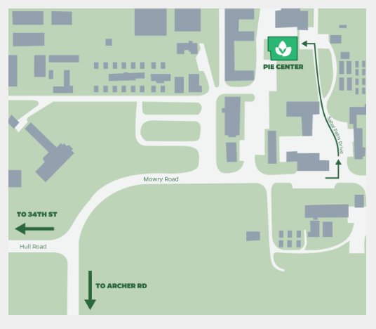
= Parking Available
= Meeting Site
Meeting taking place at the PIE Center. Parking is available at the star-marked locations – Please see Emily if you need a parking pass. Reminder: Any State, County, or Federal vehicles do not need a parking pass.

